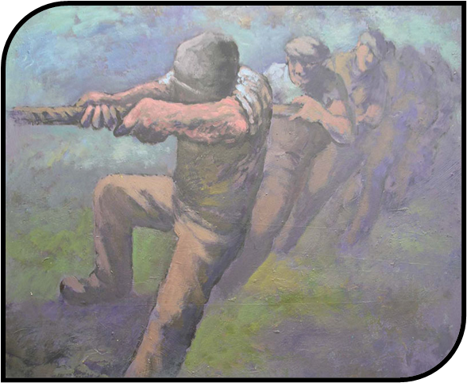

Can you copy the tones that can be seen in the picture? Record the tones in the boxes below.
What lines can be seen in the picture?
Record your answers below.
What images in the picture give us an idea of the time? Record your ideas below.
‘Tug O’ War’ by Aneurin Jones

